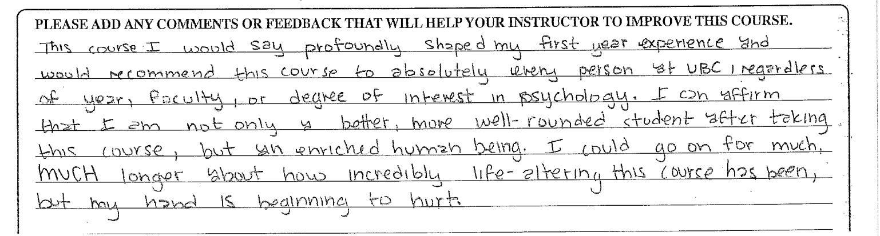
I really wanted to thank you for your class. It was truly a transformative experience and a highlight of my UBC experience.
I do great only when I am interested, inspired and feeling competent, and you and the class you taught last term has made all that happen for me.
I cannot tell you enough how valuable the information is, and how much more I wish to understand and appreciate at a deeper level and broader view. I appreciate your energy and time in supporting my learning.
I loved this class and would take it again. Adele's personal involvement with the students is notable.…She is a wonderful professor and a wealth of knowledge! She gets an A+
Loved the true seminar composition, and the instructor gave inordinate amounts of time to ensuring that all students felt comfortable participating in the discussions and discourse, even when the material was either personally or collectively challenging…. I really liked the true interdisciplinary nature of the material.
I enjoyed the class (and am amazed at how several concepts from the course have started cropping up in my life).
Adele is energetic, passionate, interesting and so impressively well-read. She explains difficult concepts well, and asks detailed and provoking questions. She sets a high standard and expects us to meet it which is great for learning. I am grateful to have had the opportunity to be in her class!
Thank you Adele for facilitating our class and managing the discussions which may have gotten tense at some points. Adele has been effective at managing the dynamics of the class and being very respectful of everyone's views. Good questions that probe deeper thinking too. I have enjoyed the class discussions tremendously and learnt a lot from the content.
Thanks for all you have given me over the past few months. I will carry what I learned from you and in your class through the rest of my life and hopefully my students and those around me will also benefit from what I learned from you.

